**1. Random Quotes**

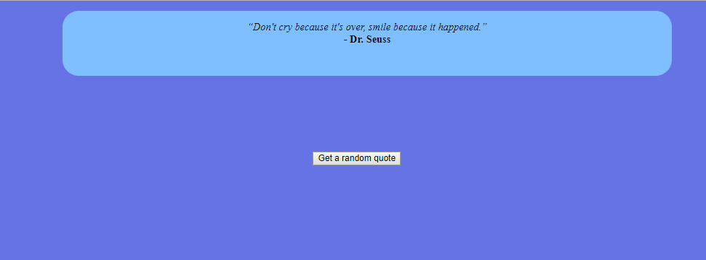

Press the button as many times as you like. Each time, a new **quote** should replace current one on screen. You can add as many **quotes** as you want into the **quotes** array. Take a look at an **overview** of our entire **project** files side by side that make up this **Random Quote** Generator.

**2. Number into Word Converter**

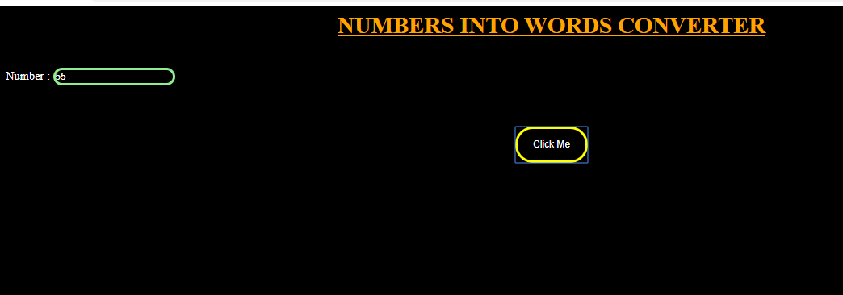

To get a **number converted** to **words** you just need to call the function passing it the **number** you want to **convert** and the corresponding **words** will be returned.

**3. Weather Report**



JavaScript fetches data from openweathermap.org (no affiliation) and makes you can access the current weather conditions and the forecast for any city.

Fetching weather data is a perfect way to get your feet wet. use the browsers built in fetch with JavaScript to grab data from OpenWeatherMap's API.

**4. Word and Char Count**

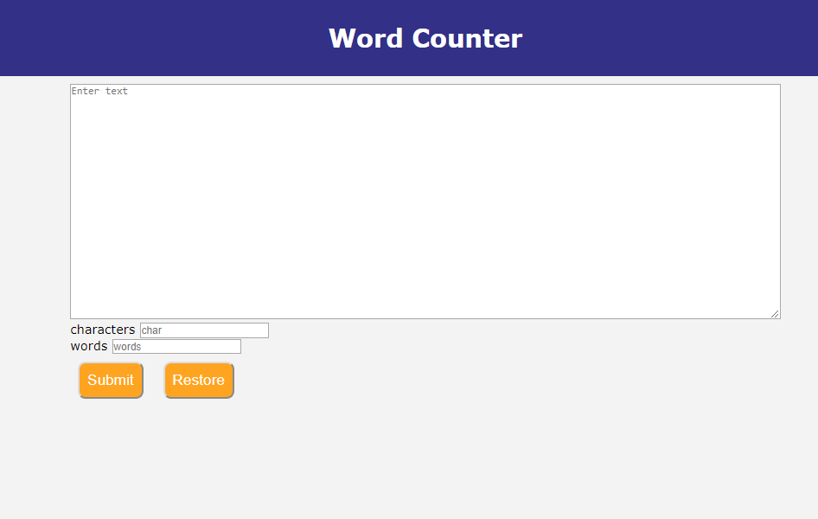

Calculate and display the number of characters and also the number of words within a TEXTAREA.

**5. Music Player**

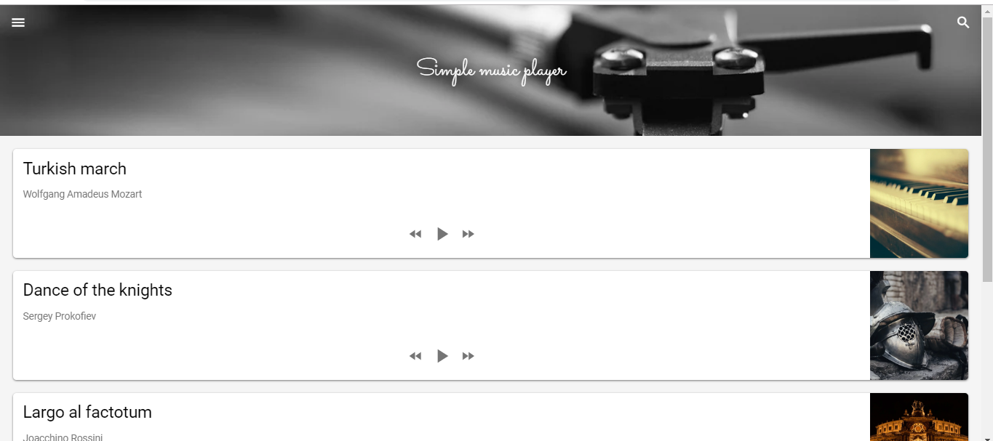

An **audio player** with play and pause buttons .Use the controls property to display audio controls (like play, pause, seeking, volume, etc…

**6. Dot and Box**

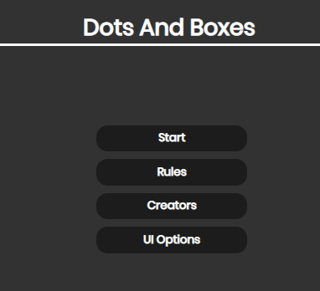

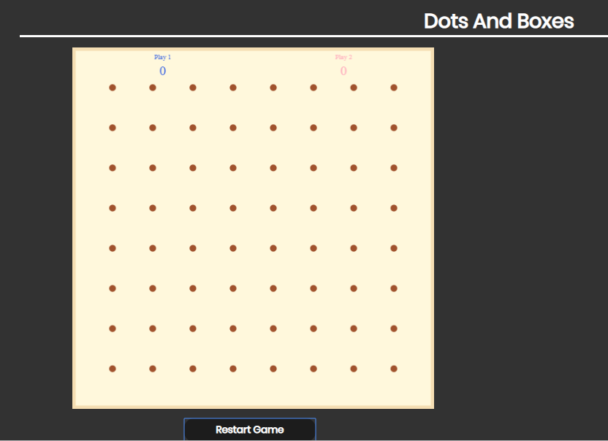

 The player who has its turn to play can add a single horizontal or vertical line between two un joined adjacent dots. In this move, if the player completes the fourth side of a box then the player owns that box, earns one point and takes another turn. Otherwise, the alternate player takes next turn to play. When a box is owned by some player, it's filled with the corresponding player's colour. The game ends when no more lines can be placed.